**BASAVARAJESWARI GROUP OF INSTITUTIONS**

# BALLARI INSTITUTE OF TECHNOLOGY & MANAGEMENT

NACC Accredited Institution*

**(Recognized by Govt. of Karnataka, approved by AICTE, New Delhi & Affiliated to Visvesvaraya Technological University, Belgavi)**

**"JnanaGangotri" Campus, No.873/2, Ballari-Hospet Road, Allipur, Ballar1- 583 104 (Karnataka) (India)**

**Ph: 08392 – 237100 / 237190, Fax: 08392 – 237197**

## DEPARTMENT OF COMPUTER SCIENCE & ENGINEERING

**A Project Report On**

**“SMART CRADLE SYSTEM”**

**A dissertation submitted to the Department of Computer Science & Engineering of Visvesvaraya Technological University in partial fulfillment for the award of the Degree of Bachelor of Engineering**

**Project Associate:**

|  |  |
| --- | --- |
| **V SHIVNARAYAN** | **3BR17CS147** |

**Under the Guidance of**

Dr. R.N. Kulkarni

Prof. & Head

**Dept of CS&E, BITM, Ballari.**

 [**Visvesvaraya Technological University**](http://www.vtu.ac.in/)

Belagavi, Karnataka 2020-2021

**BASAVARAJESWARI GROUP OF INSTITUTIONS**

# BALLARI INSTITUTE OF TECHNOLOGY & MANAGEMENT

NACC Accredited Institution*

**(Recognized by Govt. of Karnataka, approved by AICTE, New Delhi & Affiliated to Visvesvaraya Technological University, Belgavi)**

**"JnanaGangotri" Campus, No.873/2, Ballari-Hospet Road, Allipur, Ballar1- 583 104 (Karnataka) (India)**

**Ph: 08392 – 237100 / 237190, Fax: 08392 – 237197**

# DEPARTMENT OF COMPUTER SCIENCE & ENGINEERING

CERTIFICATE

This is to certify that the project work entitled “**SMART CRADLE SYSTEM**” is a bonafide work carried out by SHIVNARAYAN VAIDYANATHAN bearing USN 3BR17CS147 in partial fulfillment for the award of degree of **Bachelor Degree in Computer Science & Engineering** in the VISVESVARAYA TECHNOLOGICAL UNIVERSITY, Belagavi during the academic year 2020-2021. It is certified that all corrections and suggestions indicated for internal assessment have been incorporated in the report deposited in the library. The project has been approved as it satisfies the academic requirements in respect of project work prescribed for Bachelor of Engineering Degree.

|  |  |  |
| --- | --- | --- |
| Signature of project guide | Signature of HOD | Signature of Principal |
| **Dr. R.N. Kulkarni** | **Dr. R N Kulkarni** | **Dr. V C Patil** |

External Viva

Name of the Examiner(s) Signature with Date

1.

2.

## ABSTRACT

This project portrays the configuration of a programmed cradle which fundamentally chips away at location of infant development with the assistance of a motion sensor. Motion sensor detects the movement of infant. After the location of enlivening of infant various occasions are terminated which incorporate sending notices to parents by google firebase and e-mail, swinging of cradle with the goal that the child feels good. The cradle likewise incorporates extra gimmicks like observing the temperature of the infant to give therapeutic thoughtfulness regarding the child and cautions the parents if the body temperature of the child goes above to given threshold temperature.

**ACKNOWLEDGMENT**

Salutations to my beloved and highly esteemed institute, **“BALLARI INSTITUTE OF TECHNOLOGY & MANAGEMENT”** for having well qualified staff and labs furnished with necessary equipment.

I express my sincere thanks to my guide **Dr. R.N. Kulkarni** for giving me constant encouragement, support and valuable guidance throughout the course of the project without whose stable guidance this project would not have been achieved and I would thank my project coordinators.

I express whole hearted gratitude to **Dr. R.N. KULKARNI** who is my respectable HOD of Computer Science Dept. I wish to acknowledge his help who made my task easy by providing with his valuable help and encouragement.

And also my due thanks to **Dr. V.C. PATIL**, the Principal, as I consider myself very lucky to have such excellent computing facilities and their inspiration throughout my professional course.

I thank the non-teaching staff of CS Dept. who guided at all the time of difficulties . I also want to thank my beloved parents for their immense support in all conditions. Finally, I thank all those who are involved directly and indirectly in completion of my project.

|  |  |  |
| --- | --- | --- |
| **TABLE OF CONTENTS** | | |
| **Chapter No** | **Chapter Name** | **Page No** |
|  | Abstract | I |
|  | Acknowledgement | II |
|  | Table of Contents | III |
|  | List of Figures | IV |
| **1** | **Introduction** | 8-10 |
| 1.4 | Problem statement and Scope of project | 9 |
| 1.5 | Vision, Mission and Objectives | 10 |
| **2** | **Literature survey** | 11-13 |
| **3** | **Requirements** | 14-16 |
| 3.1 | Functional requirements | 14 |
| 3.2 | Non-functional requirements | 14-15 |
| 3.3 | Hardware requirements | 16 |
| 3.4 | Software requirements | 16 |
| **4** | **Design** | 17-27 |
| 4.1 | Smart cradle system flow chart | 17 |
| 4.2 | Motion sensor flow chart | 18 |
| 4.3 | Temperature sensor flow chart | 19 |
| 4.4  4.5  4.6  4.7  4.8  4.9  4.10  4.11 | Wet sensor flow chart  Pi camera flow chart  Raspberry pi architecture  Motion sensor circuit diagram  Temperature and humidity sensor circuit diagram  Wet sensor circuit diagram  Pi camera circuit diagram  Servo motor circuit diagram | 20  21  22  23  24  25  26  27 |
| **5** | **Implementation** | 28-40 |
| 5.1  5.2  5.3  5.4  5.5  5.6  5.7 | Main code  Camera code  G-Mail code  Main code 2  Servo motor code  Stepper motor code  Temperature and humidity sensor code | 28-32  33  34-35  36-37  38  39  40 |
|  |  |  |
|  |  |  |
| **6** | **Modules** | 41-42 |
| **7** | **Results** | 43-44 |
| 7.1 | Pi camera image | 43 |
| 7.2 | DHT11 temperature and humidity sensor image | 43 |
| 7.3 | HC-SR501 motion sensor image | 44 |
| **8** | **System testing** | 45 |
| **9**  9.1  9.2  9.3 | **Snapshots**  Temperature and humidity data  E-Mail 1  E-Mail 2 | 46-48  46  47  48 |
| **10** | **Conclusion and future scope** | 49 |
| 10.1 | Conclusion | 49 |
| 10.2 | Scope for future work | 49 |
|  | References | 50 |
|  | Appendix A | 51 |
|  | Appendix B | 52-53 |
|  | Appendix C | 54 |
|  | Appendix D | 55 |

|  |  |  |
| --- | --- | --- |
| **List of Figures** | | |
| **Sl.No.** | **Figure Name** | **Page No** |
| **Figure 4.1** | Smart cradle system flow chart | 17 |
| **Figure 4.2** | Motion sensor flow chart | 18 |
| **Figure 4.3** | Temperature sensor flow chart | 19 |
| **Figure 4.4** | Wet sensor flow chart | 20 |
| **Figure 4.5** | Pi camera flow chart | 21 |
| **Figure 4.6** | Raspberry pi architecture | 22 |
| **Figure 4.7** | Motion sensor circuit diagram | 23 |
| **Figure 4.8** | Temperature and humidity sensor circuit diagram | 24 |
| **Figure 4.9** | Wet sensor circuit diagram | 25 |
| **Figure 4.10** | Pi camera circuit diagram | 26 |
| **Figure 4.11** | Servo motor circuit diagram | 27 |
| **Figure 7.1** | Pi camera image | 43 |
| **Figure 7.2** | DHT11 temperature and humidity sensor image | 43 |
| **Figure 7.3** | HC-SR501 motion sensor image | 44 |
| **Figure 9.1** | Temperature and humidity data | 46 |
| **Figure 9.2** | E-Mail 1 | 47 |
| **Figure 9.3** | E-Mail 2 | 48 |

**CHAPTER 1**

**INTRODUCTION**

**1.1 OVERVIEW**

As we all know the term IOT that is internet of things which is designed to save time and ease work. As far as time and security is concerned with the help of IOT we will build a cradle system which will reduce the stress of parents or guardians and most importantly provide safe and comfortable experience for the baby. So, managing work and taking care of baby are very important factors. Smart cradle system will help parents or guardians to parent baby in case they do not have time like if both the parents go to work or are busy with something else. A stress free atmosphere is good for the baby. So, it doesn’t matter if there is no one to swing the cradle as the system would automatically do it. Proposed system will help parents or guardians to take good care of baby.

**1.2 EXISTING SYSTEM**

**Limitations of the existing system:**

* The cradle needs to be operated manually.
* Doesn’t come with any additional features to monitor various parameters like temperature, humidity or movement.
* Baby needs to be taken care of in person 24/7.

**1.3 PROPOSED SYSTEM**

**Benefits of proposed system:**

* Cradle can be remotely operated.
* Saves time for user engaged in some other work.
* Comes equipped with additional features like temperature and humidity measurement.
* Notifies user regarding baby’s condition through the measurement of various parameters like temperature, humidity, wetness or movement.

## PROBLEM STATEMENT AND SCOPE OF THE PROJECT

**Problem statement**

To design and develop a smart cradle system for remote monitoring of baby as well provide safe and comfortable experience to cradled infants.

**Scope of the project**

The scope of the project is to develop a smart cradle system to provide comfortable experience to baby. The system employs different types of tools such as motion sensor for motion detection and camera for remote monitoring. This project is suitable for those parents and guardians who may not have enough time to take care of their baby.

**1.5 VISION,MISSION AND OBJECTIVES**

**Vision**

Deliver best cradle system for a comfortable experience to cradled infants.

**Mission**

To build state of the art cradle system with various features such as motion detection and remote monitoring for proper baby care.

## Objectives

* Todevelop a smart baby care system with features for monitoring baby movements.
* To detect bed-wet condition and body temperature of baby care system.
* To automate cradle that is flexible and reliable.
* To model a user friendly system.

**CHAPTER 2**

**LITERATURE SURVEY**

**2.1 LIST OF RESEARCH PAPERS**

Some survey papers which states problems with respect to baby care are as follows:

**Paper [1]:** “General Idea about Smart Baby Cradle” published in 2016. In this research paper the author states that cradle will swing automatically. But the proposed system was making too much noise while swinging which disturbed the baby’s sleep.

**Paper[2]:** “Development of an Intelligent Cradle for Home and Hospital Use” published in 2015. In this research paper author states that system is designed to monitor baby movement, bed-wet condition and body temperature. The system had three modules but it did not have the most important feature that is automatic cradle swing.

**Paper [3]:** “An Automatic Monitoring and Swing the Baby Cradle for Infant Care” published in 2015. In this research paper the author states that there is automatic swing feature along with facial expression detector but because of the use of artificial intelligence the cost of the system was high.

**Paper [4]:** “Smart baby cradle” was published in 2018. In this paper author states that there are features like wetness detection, cradle swing, camera monitoring etc. But there was no facility to measure the room and body temperature of baby.

**Paper [5]:** Dhake, Swati. (2021). A Smart Baby Monitoring System an IOT based Smart Cradle System. International Journal for Research in Applied Science and Engineering Technology. 9. 635-642. 10.22214/ijraset.2021.35004.This paper presents the planning of good Cradle that supports video observation. The Cradle swings mechanically on detection of baby’s cry. Baby care has become a daily challenge for several families. Thus, most parents send their babies to their grandparent’s house or to baby care homes. However, grandparents cannot ceaselessly monitor their baby’s condition. Therefore, an internet of things-based baby monitoring system is projected as associate in nursing economical and low-priced iot-based system for observation in real time. We also provide live video policing, that plays a key role in providing higher baby care.

**Paper [6]:** Duman, ülkü & Aydin, Erdogan. (2020). IOT Based Baby Cradle System with Real Time Data Tracking. 10.1109/UBMK50275.2020.9219506. This paper states that, In today's industrialized countries, women's participation in the workforce has dramatically increased. This participation is one of the main reasons that affect baby care in many families from the birth of the baby to a certain age. The most important factors that should be followed in infants are body temperature and sleep patterns, which we can call vital functions. An abnormal increase in the temperature of the baby during sleep is one of the most critical factors causing sudden infant death syndrome, a febrile complication. In this article, an internet of things (IoT) based baby monitoring mechanism, namely a smart cradle structure, which tracks the real-time temperature, heart rate, wetness and sound of the baby is proposed, and the data received from the sensors will be transferred to a web platform via Wi-Fi and checked in real-time. In the case of crying, the cradle will swing autonomously. Alarm will be activated if crying does not stop or if an abnormal increase in the measured body temperature, heart rate and humidity level is observed.

**Paper [7]:** Kshirsagar,Pravin (2021). INTERNET OF THINGS-BASED BABY MONITORING SYSTEM FOR SMART CRADLE. Journal of Resource Management and Technology. 12. 217-225. The objective of this paper is to implement an intelligent baby monitoring system, which makes it possible to detect automatically, remotely and in real time the crying and movements of infant in cradle as well as to monitor the temperature of room. It is based on controller card, pi camera, sound sensor and temperature sensor to recover sufficient information concerning the baby.

**Paper [8]:** Sharma, Siddharth & Bhatnagar, Swapnil & Hasan, Sharjeel & Jain, Vibhor & Patil, Amruta. (2021). This paper explains regular Automatic child cradle foundation which are mainly high end and in addition don't offer much practicality. In recent times the progress of high-tech electronics has introduced the concept of intelligent baby cradle as a smart system with

many features to minimize the efforts of parents and guardians. The paper is directed to better quality of the in subsist baby cradle systems by making changes in a new module, thus simplifying baby care. In case baby cries parents are alerted regarding the same. The survey paper shows the format of a functional cradle which will show signs of malfunctioning at space of infant development with the assistance of a Passive infrared (PIR) sensor. Passive infrared (PIR) sensor senses movement of baby in cradle. The movement of infant on different occasions are eliminated which would get attention of nearby person by making a sound via buzzer, swinging of cradle, keeping in mind child's ease. If the baby doesn't rest or stop crying after a certain period of time then buzzer is used to alert parents informing them that, their child needs attention. The cradle has various sensors including wet sensor which will symbolize person nearby or attendant that baby has wetted bed. So, accordingly parents will know what precaution needs to be taken.

**CHAPTER 3**

**REQUIREMENTS**

## FUNCTIONAL REQUIREMENTS

* The System should be able to perform various tasks such as detecting baby’s movement, check for bed-wet condition, check body temperature etc.
* Notification regarding baby’s condition should be sent to parents/guardians at regular intervals.
* The system should be able to soothe baby to make it feel comfortable.
* The system should also have a monitoring system to monitor baby.

## NON FUNCTIONAL REQUIREMENTS

* **Reliability** : The capability to maintain specified level of performance is called reliability. Unauthorized person will not be able to use the system.
* **Availability** : The system must be readily available to users, (24*7).
* **Security** : System must be highly secured and must authenticate users strictly.
* **Maintainability** : System must be easy to maintain. Users should be able to sort any issue that arise.
* **Accessibility** : Should be accessible by members to whom the user has grant access.
* **Scalability** : The system should be able to accommodate additional features when required.

# HARDWARE REQUIREMENTS

* Intel Core i3 and above
* Ram : 2gb and above
* Hard disk space : 100 gb and above
* SD card : 16gb or above
* SD card reader : USB 2.0 or above
* Motion sensor (HC-SR501)
* Temperature and wet sensor (dht11)
* Wet sensor (EC-1258)
* Power source (5 Volt charger)
* Geared motor (10 rpm,6V)
* Ethernet cable

# 

# SOFTWARE REQUIREMENTS

* Operating System : Windows 7 or higher version OS
* Language : Python
* Advanced IP Scanner (v 2.5)
* MobaXterm (v 21.1)
* Raspberry Pi OS (v 5.1)
* Thonny IDE (v 3.3)
* Google Firebase (v 5.0)

# CHAPTER 4

# DESIGN

## SMART CRADLE SYSTEM FLOW CHART

## C:\Users\HP\Desktop\Sabarish\Smart Cradle Flowchart.jpg

Fig: 4.1 Smart Cradle System Flow Chart

* 1. **MOTION SENSOR FLOW CHART**

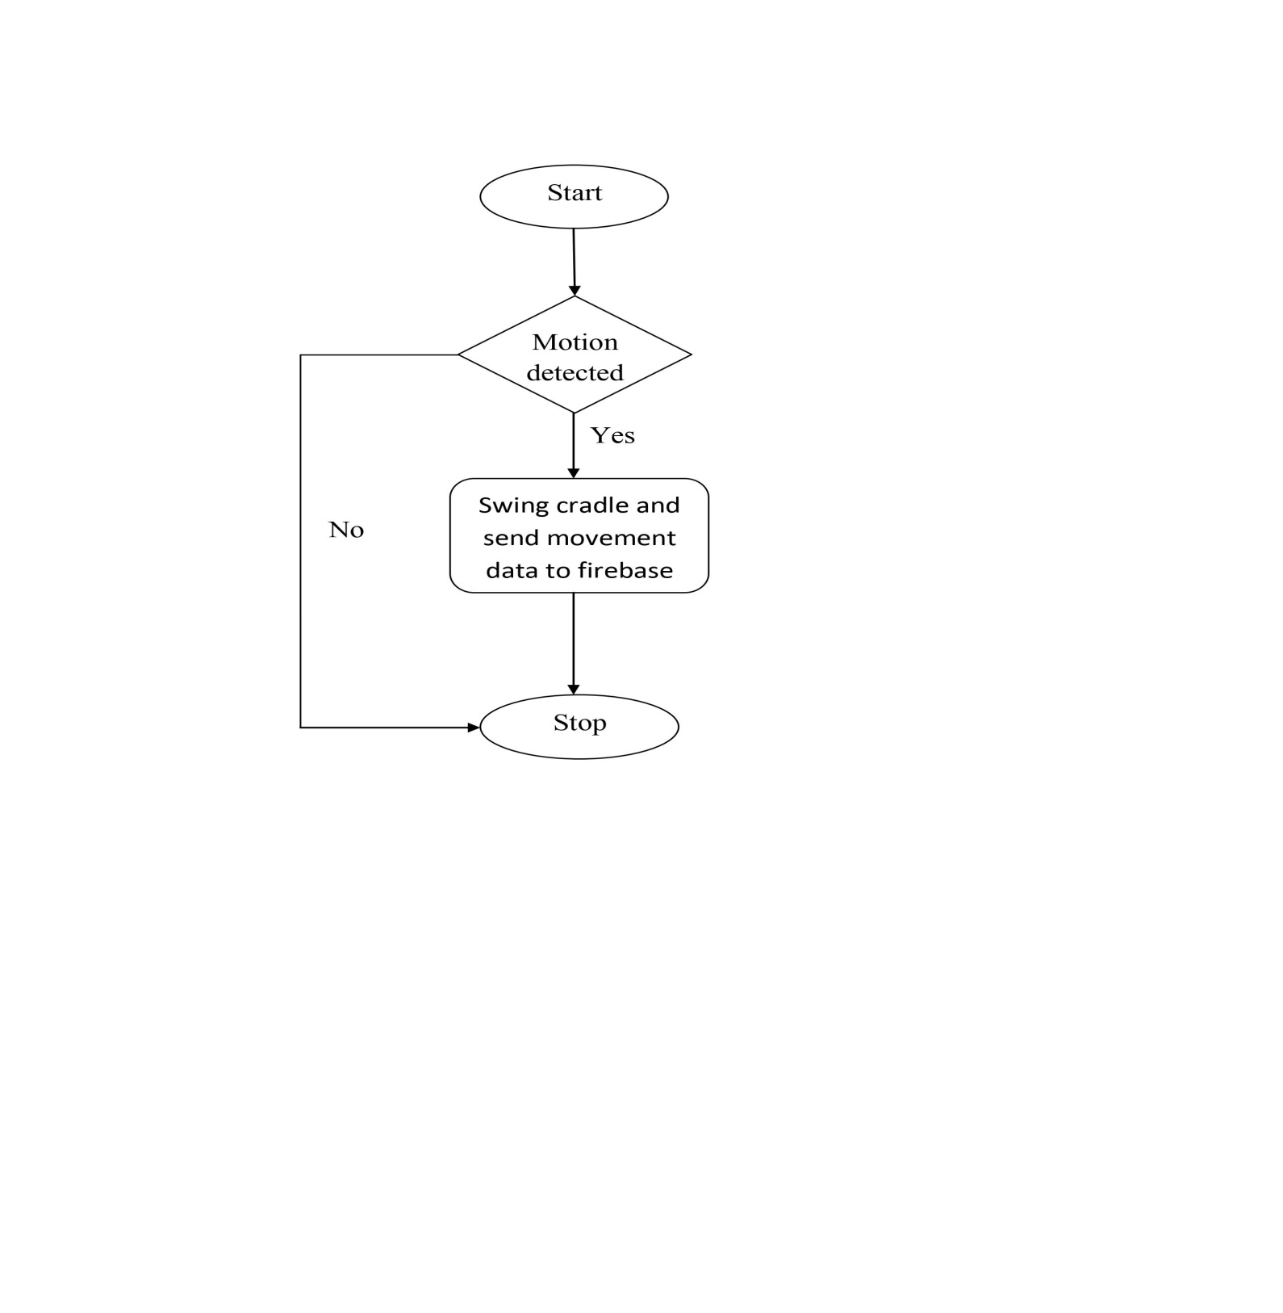

Fig 4.2 Motion Sensor Flow Chart

* 1. **TEMPERATURE SENSOR FLOW CHART**

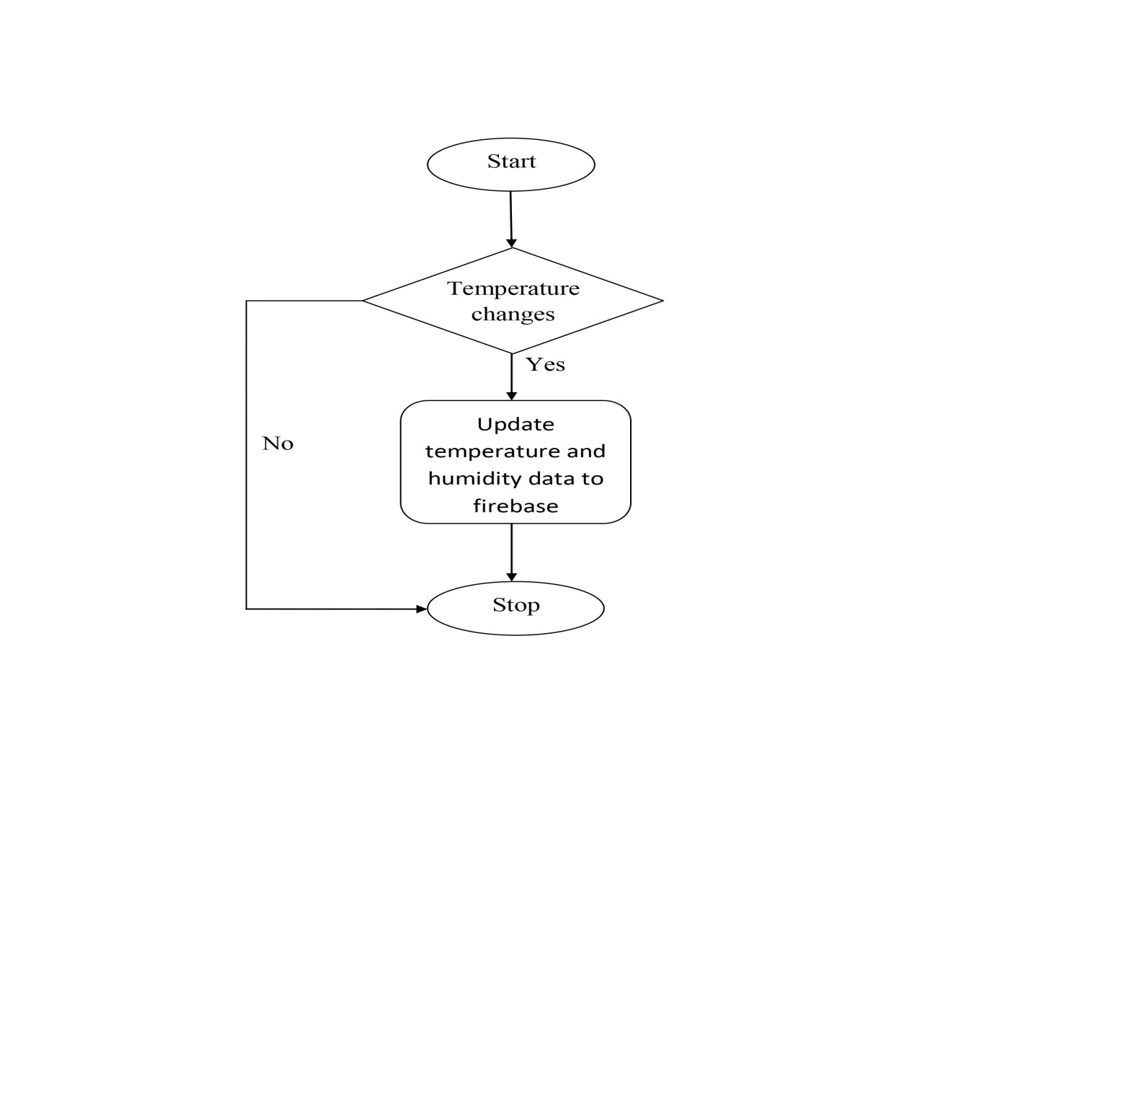

Fig 4.3 Temperature Sensor Flow Chart

* 1. **WET SENSOR FLOW CHART**

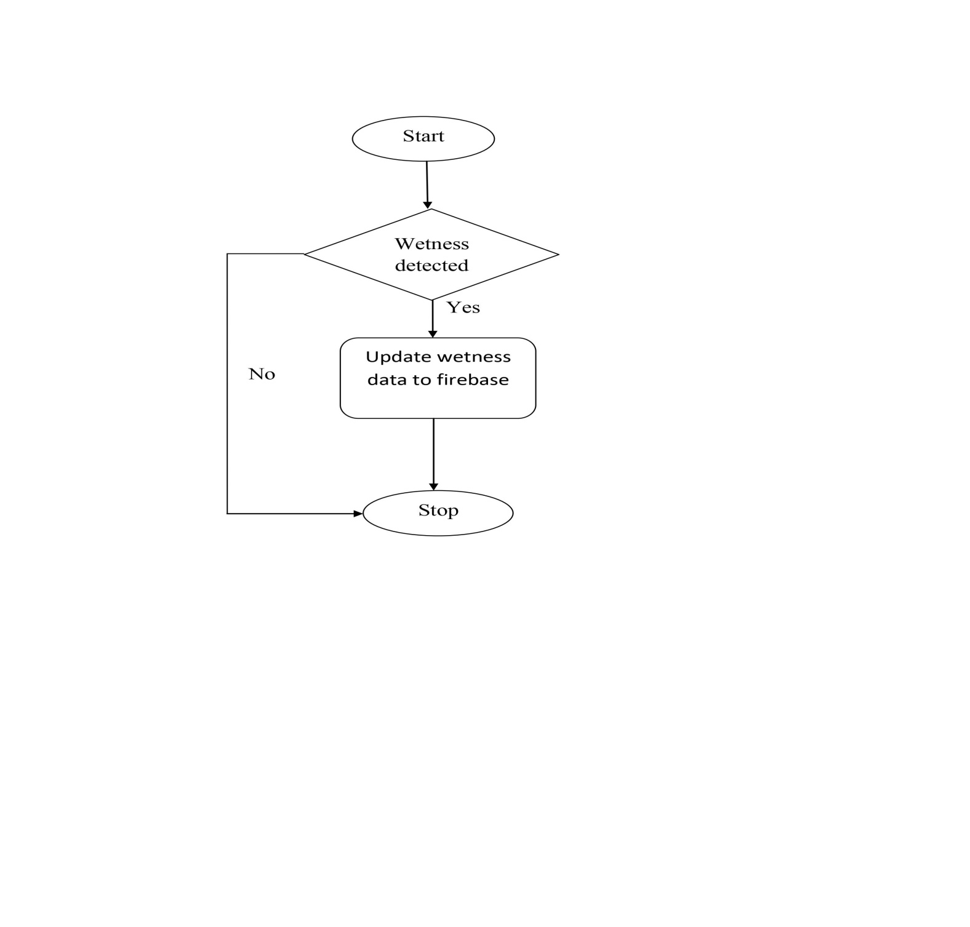

Fig 4.4 Wet Sensor Flow Chart

* 1. **PI CAMERA FLOW CHART**

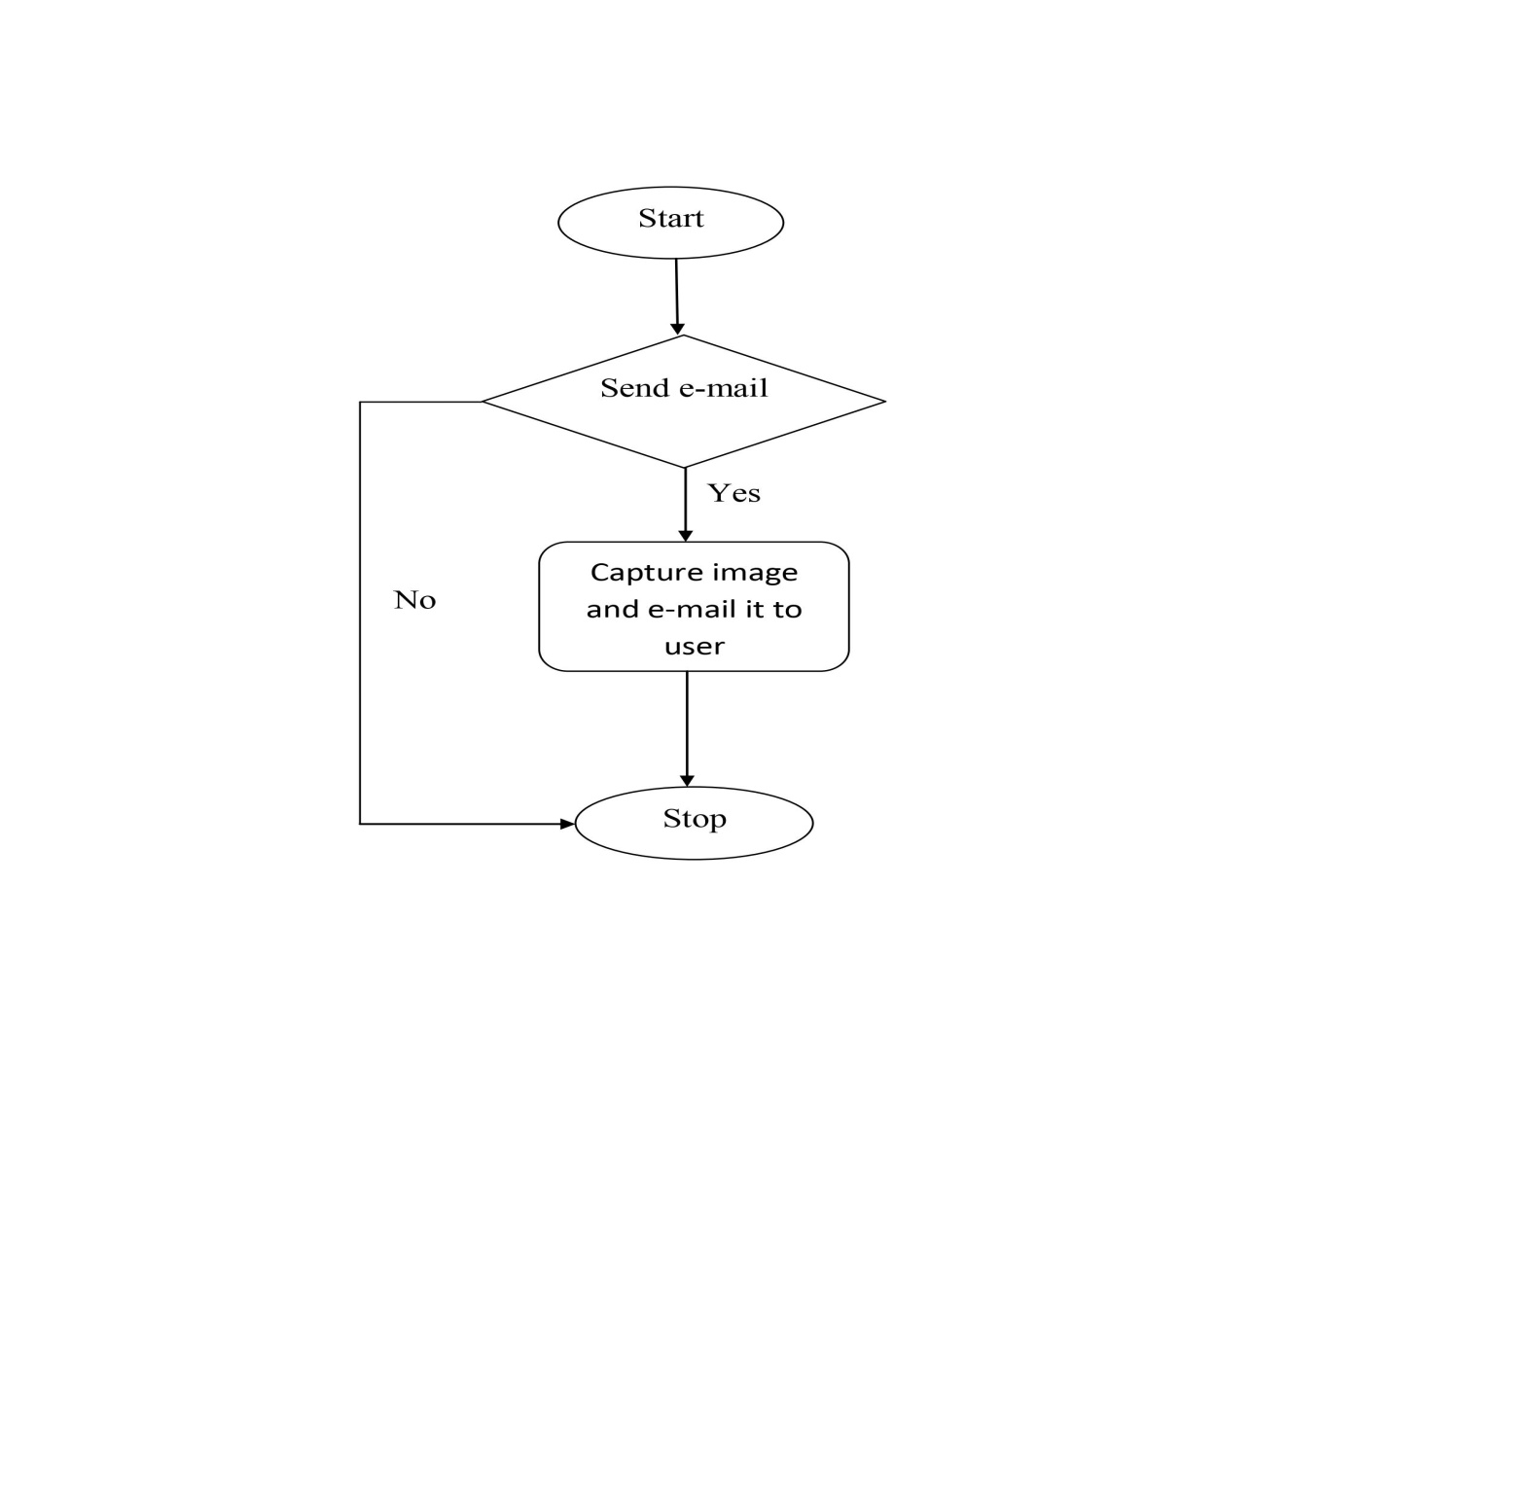

Fig 4.5 Pi Camera Flow Chart

* 1. **RASPBERRY PI ARCHITECTURE**

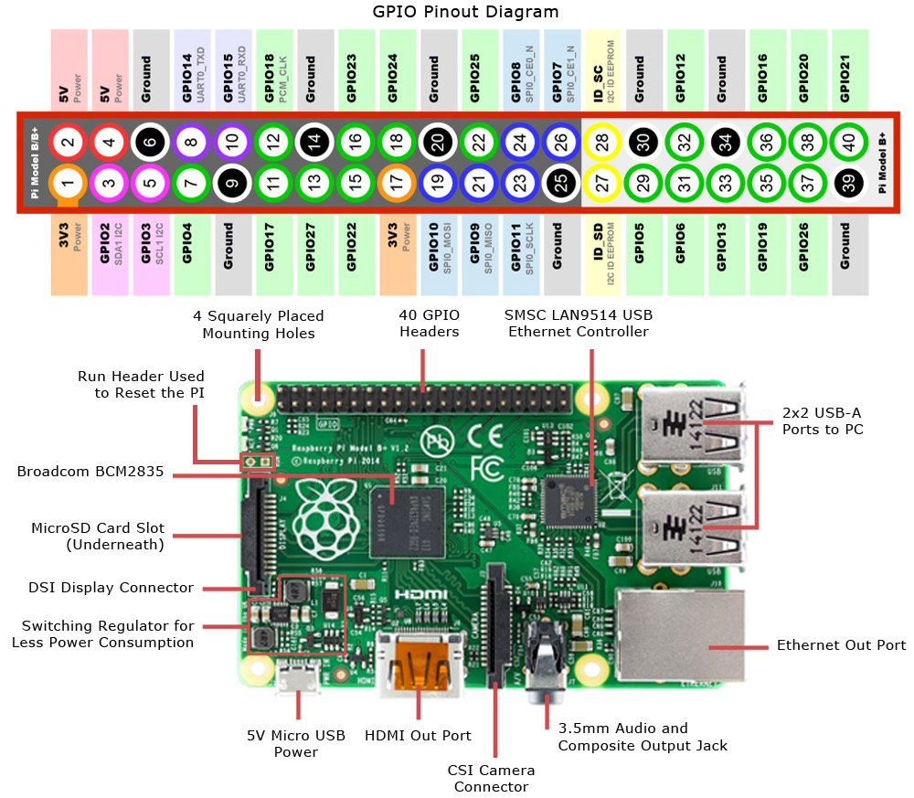

Fig 4.6 Raspberry Pi Architecture

* 1. **MOTION SENSOR CIRCUIT DIAGRAM**

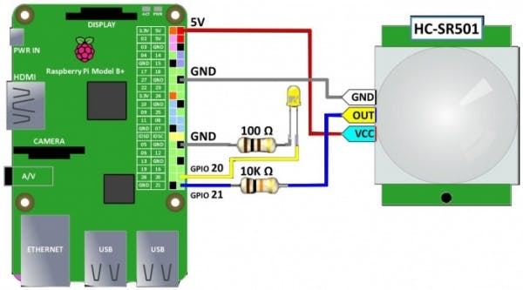

Fig 4.7 Motion Sensor Circuit Diagram

* 1. **TEMPERATURE AND HUMIDITY SENSOR CIRCUIT DIAGRAM**

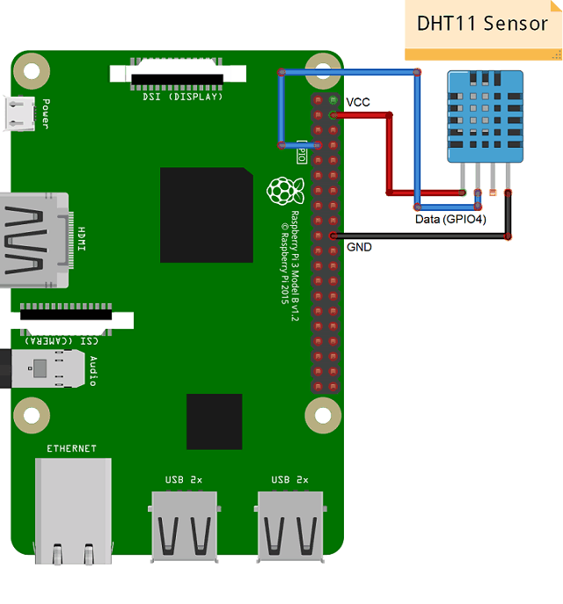

Fig 4.8 Temperature and Humidity Sensor Circuit Diagram

* 1. **WET SENSOR CIRCUIT DIAGRAM**

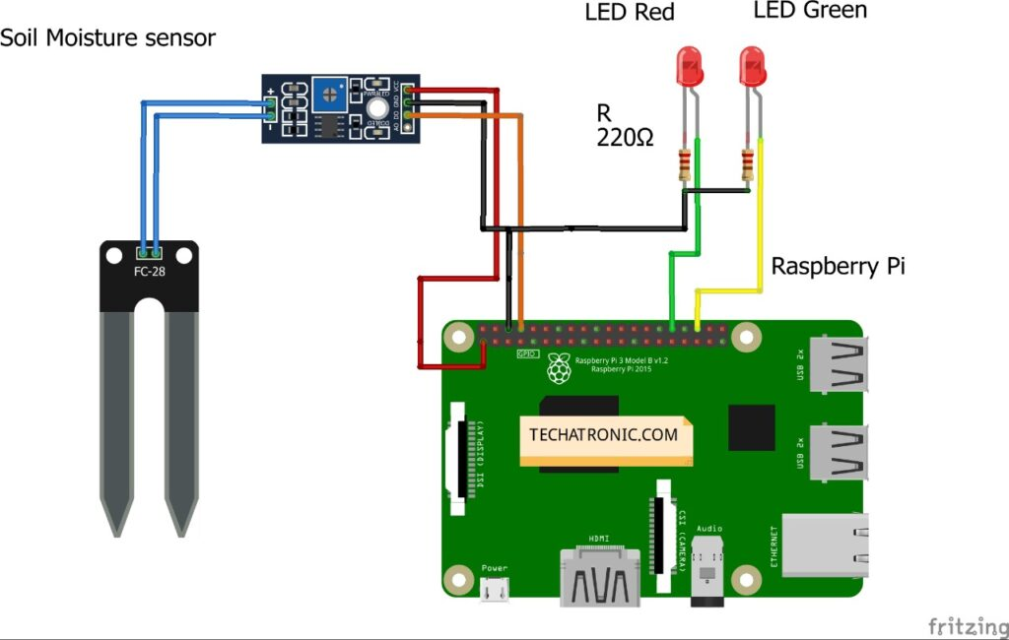

Fig 4.9 Wet Sensor Circuit Diagram

* 1. **PI CAMERA CIRCUIT DIAGRAM**

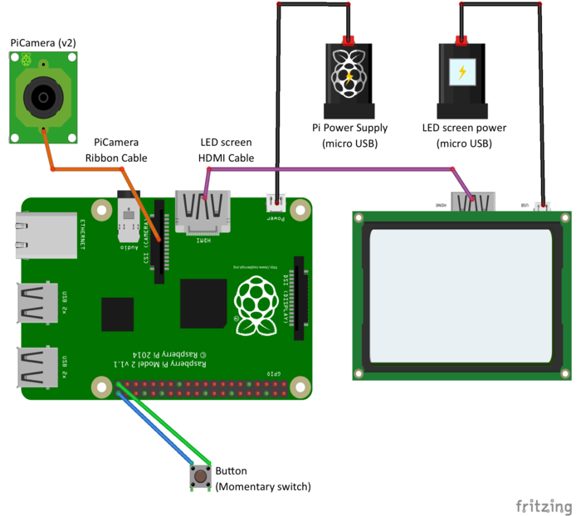

Fig 4.10 Pi Camera Circuit Diagram

* 1. **SERVO MOTOR CIRCUIT DIAGRAM**

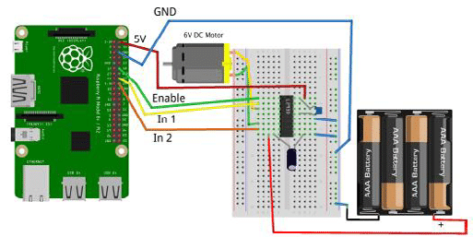

Fig 4.11 Servo Motor Circuit Diagram

**CHAPTER 5**

**IMPLEMENTATION**

**5.1 MAIN CODE**

from firebase import firebase

firebase = firebase.FirebaseApplication('https://baby-monitoring-4a0f5-default-rtdb.firebaseio.com/', None)

import time

import cv2

import imutils

import os

import smtplib

from email.mime.multipart import MIMEMultipart

from email.mime.text import MIMEText

from email.mime.base import MIMEBase

from email import encoders

import pyfiglet

from datetime import datetime

import camera

#import stepper

import main

import servomotor

def mail():

fromaddr = "eration6@gmail.com"

toaddr = "kannihya@gmail.com"

# instance of MIMEMultipart

msg = MIMEMultipart()

# storing the senders email address

msg['From'] = fromaddr

# storing the receivers email address

msg['To'] = toaddr

# storing the subject

msg['Subject'] = "Image"

# string to store the body of the mail

body = "Hi, find the attached Image"

# attach the body with the msg instance

msg.attach(MIMEText(body, 'plain'))

# open the file to be sent

camera.main()

filename="baby.jpg"

attachment = open(filename, "rb")

# instance of MIMEBase and named as p

p = MIMEBase('application', 'octet-stream')

# To change the payload into encoded form

p.set_payload((attachment).read())

# encode into base64

encoders.encode_base64(p)

# attach the instance 'p' to instance 'msg'

p.add_header('Content-Disposition', "attachment; filename= %s" % filename)

msg.attach(p)

# creates SMTP session

s = smtplib.SMTP('smtp.gmail.com', 587)

# start TLS for security

s.starttls()

# Authentication

s.login(fromaddr,"Project@123")

# Converts the Multipart msg into a string

text = msg.as_string()

# sending the mail

s.sendmail(fromaddr, toaddr, text)

# terminating the session

s.quit()

while True:

i,j,humidity,temperature=main.main()

print("all sensor values",i,j,humidity,temperature)

send_email = firebase.get('send_email',None)

print("mail value",send_email)

s1 = firebase.get('servo',None)

print("servo value",s1)

firebase.put("",'movement',i)

firebase.put("",'temperature',temperature)

firebase.put("",'humidity',humidity)

firebase.put("",'wet',j)

if s1 == "1":

#cv2.imwrite("C:/Users/Admin/Desktop/PROJECT_CODE/image.jpg",frame)

print("########## moving cradle ############\n")

servomotor.main()

firebase.put('','servo',"0")

if send_email == "1":

#cv2.imwrite("C:/Users/Admin/Desktop/PROJECT_CODE/image.jpg",frame)

print("########## SENDING EMAIL ############\n")

mail()

print("............\n")

print("########## EMAIL SENT ############\n")

firebase.put('','send_email',"0")

cv2.destroyAllWindows()

cap.release()

**5.2 CAMERA CODE**

from picamera import PiCamera

from time import sleep

import cv2

def main():

print("starting camera")

camera = PiCamera()

camera.start_preview()

sleep(5)

camera.capture('baby.jpg')

camera.stop_preview()

camera.close()

filename = 'baby.jpg'

img=cv2.imread("baby.jpg")

cv2.imshow("Frame", img)

cv2.waitKey(0)

print("image captured")

#main()

**5.3 G-MAIL CODE**

# Python code to illustrate Sending mail with attachments

# from your Gmail account

# libraries to be imported

import smtplib

from email.mime.multipart import MIMEMultipart

from email.mime.text import MIMEText

from email.mime.base import MIMEBase

from email import encoders

def main(file):

fromaddr = "eration6@gmail.com"

toaddr = "kannihya11@gmail.com"

# instance of MIMEMultipart

msg = MIMEMultipart()

# storing the senders email address

msg['From'] = fromaddr

# storing the receivers email address

msg['To'] = toaddr

# storing the subject

msg['Subject'] = "Subject of the Mail"

# string to store the body of the mail

body = "Body_of_the_mail"

# attach the body with the msg instance

msg.attach(MIMEText(body, 'plain'))

# open the file to be sent

filename = "animal.jpg"

attachment = open(file, "rb")

# instance of MIMEBase and named as p

p = MIMEBase('application', 'octet-stream')

# To change the payload into encoded form

p.set_payload((attachment).read())

# encode into base64

encoders.encode_base64(p)

p.add_header('Content-Disposition', "attachment; filename= %s" % filename)

# attach the instance 'p' to instance 'msg'

msg.attach(p)

# creates SMTP session

s = smtplib.SMTP('smtp.gmail.com', 587)

# start TLS for security

s.starttls()

# Authentication

s.login(fromaddr, "Project@123")

# Converts the Multipart msg into a string

text = msg.as_string()

# sending the mail

s.sendmail(fromaddr, toaddr, text)

# terminating the session

s.quit()

print("mail sent")

**5.4 MAIN CODE 2**

import RPi.GPIO as GPIO

import time

import servomotor

import gmail

from picamera import PiCamera

from time import sleep

GPIO.setwarnings(False)

import camera

#GPIO.setmode(GPIO.BOARD)

GPIO.setup(17, GPIO.IN)#Read output from PIR motion sensor

GPIO.setup(14, GPIO.IN)#Read output from PIR motion sensor

import temp

def main():

i=GPIO.input(17)

j=GPIO.input(14)

humidity,temperature=temp.main()

if i==0: #When output from motion sensor is LOW

print ("No movement")

time.sleep(1)

if i==1: #When output from motion sensor is HIGH

print ("movement detected")

time.sleep(1)

servomotor.main()

if j==1: #When output from motion sensor is LOW

print ("No wet")

time.sleep(1)

if j==0: #When output from motion sensor is HIGH

print ("wet detected")

time.sleep(2)

return i,j,humidity,temperature

#main()

**5.5 SERVO MOTOR CODE**

import RPi.GPIO as GPIO

import time

servoPIN = 18

GPIO.setmode(GPIO.BCM)

GPIO.setup(servoPIN, GPIO.OUT)

def main():

p = GPIO.PWM(servoPIN, 50) # GPIO 17 for PWM with 50Hz

p.start(0) # Initialization

p.ChangeDutyCycle(5)

time.sleep(0.5)

p.ChangeDutyCycle(10)

time.sleep(0.5)

p.ChangeDutyCycle(5)

time.sleep(0.5)

p.ChangeDutyCycle(10)

time.sleep(0.5)

p.ChangeDutyCycle(5)

time.sleep(0.5)

p.ChangeDutyCycle(10)

time.sleep(0.5)

p.ChangeDutyCycle(0)

**5.6 STEPPER MOTOR CODE**

from time import sleep

import RPi.GPIO as GPIO

from RpiMotorLib import RpiMotorLib

#define GPIO pins

GPIO_pins = (14, 15, 18) # Microstep Resolution MS1-MS3 -> GPIO Pin

direction= 20 # Direction -> GPIO Pin

step = 21 # Step -> GPIO Pin

# Declare an named instance of class pass GPIO pins numbers

mymotortest = RpiMotorLib.A4988Nema(direction, step, GPIO_pins, "A4988")

def test(angle):

print("Rotating Anti Clockwise")

mymotortest.motor_go(False, "1/8" , angle,.01, False, 0.5)

sleep(4)

print("Rotating Clockwise")

mymotortest.motor_go(True, "1/8" , angle,.01, False, 0.5)

# test(325)

**5.7 TEMPERATURE AND HUMIDITY SENSOR CODE**

import sys

import Adafruit_DHT

import time

def main():

humidity, temperature = Adafruit_DHT.read_retry(11, 15)

print(humidity,temperature)

print ('Temp: {0:0.1f} C Humidity: {1:0.1f} %'.format(temperature, humidity))

time.sleep(1)

return humidity,temperature

**CHAPTER 6**

**MODULES**

1. **Raspberry Pi Operating System:**

* The user can interact with smart cradle through raspberry pi operating system. The operating system consists of a python editor thonny.
* User can operate the cradle by running the main python code through thonny editor.
* User will be able to view all the sensor values in the thonny editor as well as whether e-mail is being sent or the servo motor is on or off.

1. **Google Firebase:**
   * + In this module the user will be able to control the servo motor as well as camera. The user has to specify the value of servo motor and camera (defined as e-mail) as either 0 or 1.Here the value 0 represents off and 1 represents on.
     + Initially the value of servo motor and camera will be 0, user can change these values as 1.Once the value is 1 both the motor and camera will be on. Camera will take a snapshot of infant and e-mail it to parents. While cradle will swing to sooth the baby.
     + Additionally the firebase also displays temperature, humidity, wetness and movement values.
2. **MobaXterm:**

* Since raspberry pi itself is a computer, user needs an application to remotely access it via his/her computer. MobaXterm is an application used to remotely access raspberry pi.
* The user has to specify the ip address of raspberry pi which is connected to the internet via Ethernet cable or wifi to start a session.
* Once the session starts user needs to specify the username and password. Next step is to type startlxde to gain access to raspberry pi.

1. **Advanced IP Scanner:**

* Advanced IP Scanner is an application used to locate raspberry pi in network.
* User needs to specify the ip address range in search bar and then press scan.
* Application will then display all the devices connected to network within the ip address range specified.
* Devices that are active in network are specified as live while one’s that are not active are specified as dead.
* User needs to copy the ip address of raspberry pi and then need to paste the same in mobaxterm application to gain access to raspberry pi.

## CHAPTER 7

## RESULTS

The proposed system performs the following operations:

1. Remote monitoring - Pi camera is used to capture image of the infant and e-mail it to user.

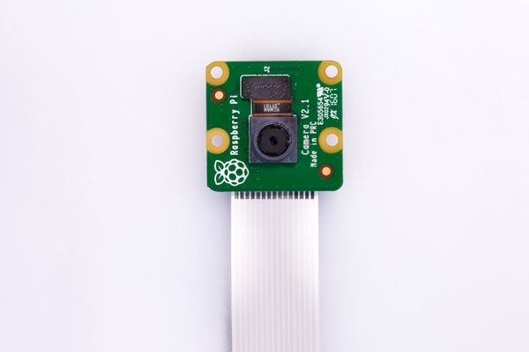

Fig 7.1 Pi Camera Image

2. Measuring baby’s temperature - DHT11 sensor is used to measure baby’s body temperature.

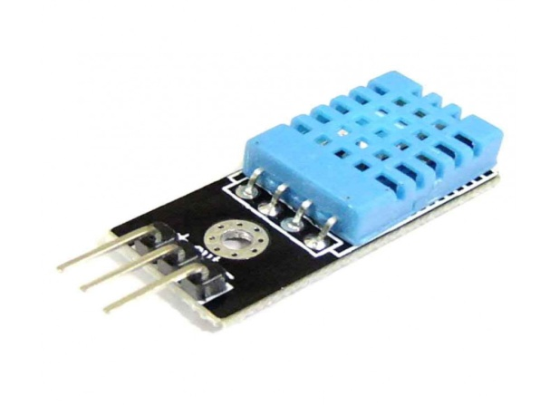

Fig 7.2 DHT11 Temperature and Humidity Sensor Image

3. Detecting baby’s movements through motion sensor - HC-SR501 motion sensor is used to detect baby’s movements.

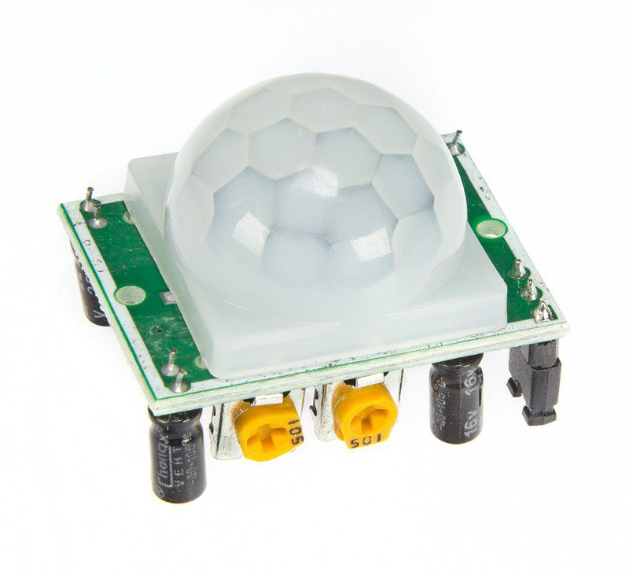

Fig 7.3 HC-SR501 Motion Sensor

1. Swing the cradle to soothe baby if it feels uncomfortable – An automated cradle is used for this purpose.

**CHAPTER 8**

**SYSTEM TESTING**

|  |  |  |  |  |  |  |  |
| --- | --- | --- | --- | --- | --- | --- | --- |
| **SL No.** | **Process** | **Test Case** | **Steps** | **Description** | **Status** | **Expected Results** | **Actual Results** |
| 1 | Webcam | Remote monitoring | 1 | Used to remotely monitor baby | Success | Switch on to monitor the baby | Executed successfully |
| 2 | Temperature and wet sensor | Detect temperature and humidity (moisture) | 1  2 | Collect temperature and humidity reading  Send the data to user via e-mail | Success | Detect and send the data to user | Data collected and sent |
| 3 | Motion sensor | Detect baby’s movement | 1 | Checks whether the baby is within the cradle or not, in case if there is any issue it alerts the user. | Success | Detect baby’s movements | Executed successfully |
| 4 | Geared motor | Swing cradle | 1 | Swings the cradle to soothe baby if uncomfortable | Success | Swing cradle | Executed successfully |

# CHAPTER 9

# SNAPSHOTS

**9.1 TEMPERATURE AND HUMIDITY DATA**

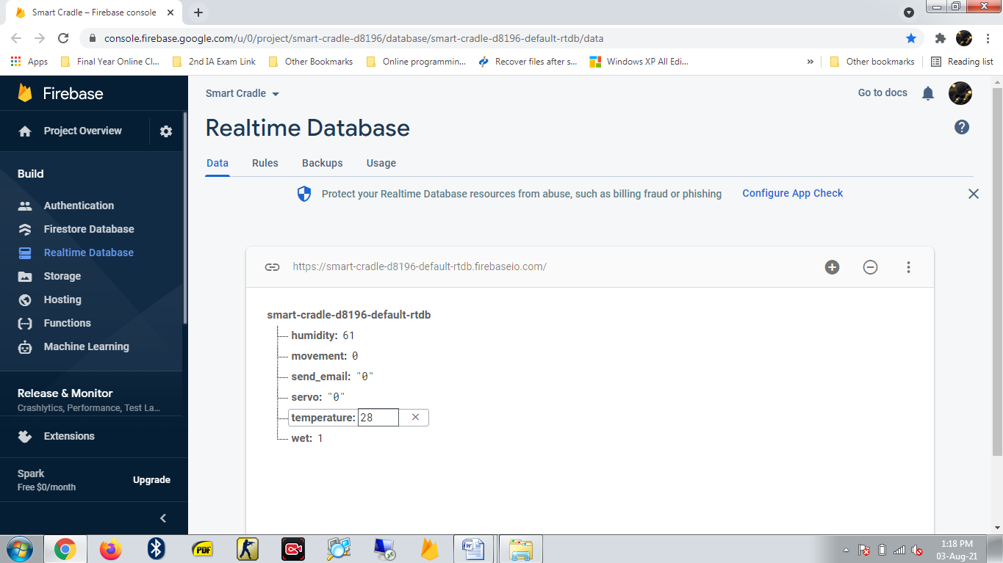

Fig 8.1 Temperature and Humidity data

**9.2 E-MAIL 1**

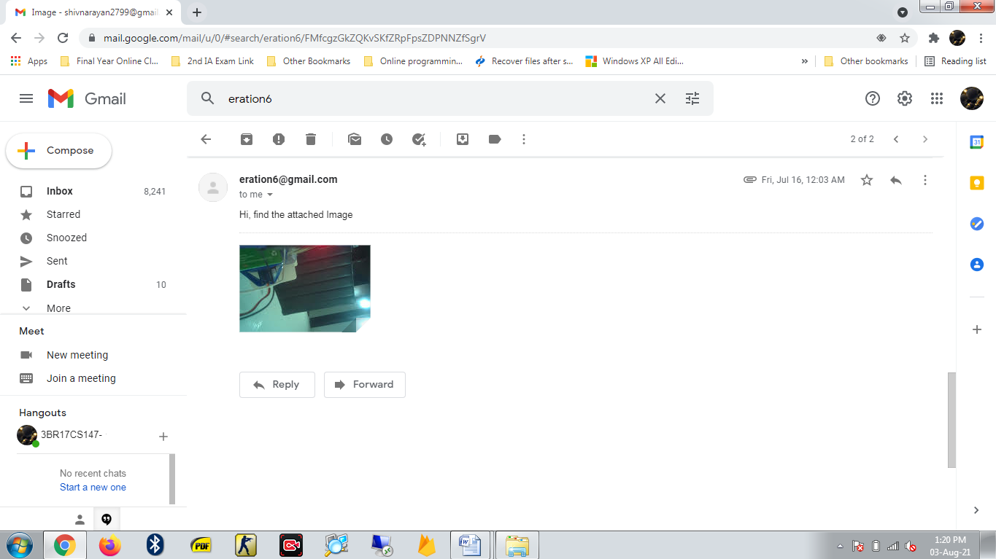

Fig 8.2 E-Mail 1

**9.3 E-MAIL 2**

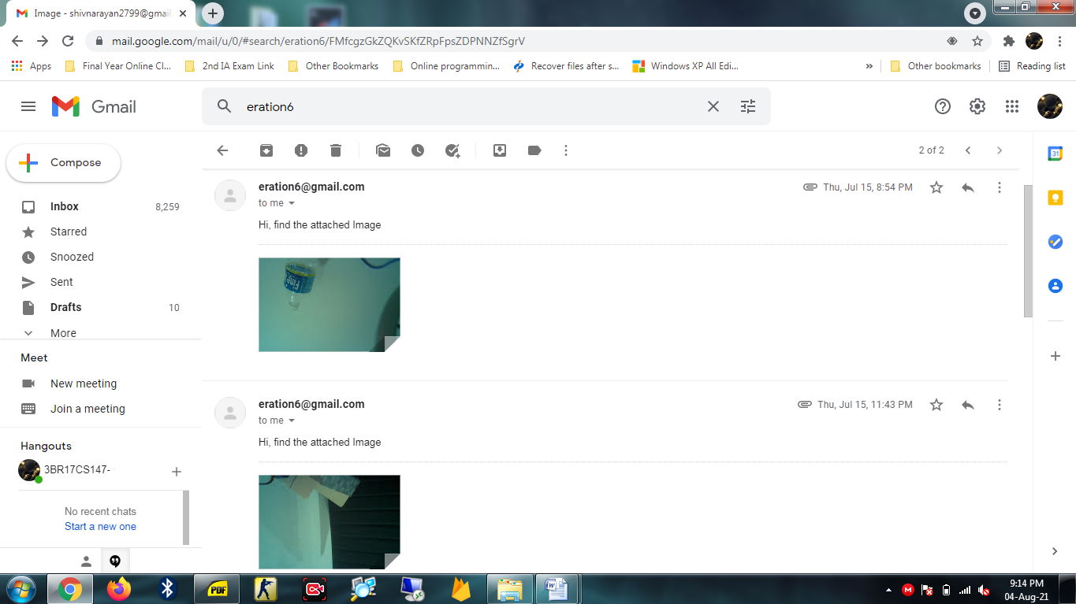

Fig 8.3 E-Mail 2

**CHAPTER 10**

**CONCLUSION AND FUTURE SCOPE**

**10.1 CONCLUSION**

Growth of technology has rapidly increased. Since technology has been developed greatly it can contribute to the society in various way. Smart cradle system is the best example where working parents have lot of workload already and they have to take care of baby as well. Smart cradle system assures them that their baby is safe and secure inside the cradle. Cradle which is less expensive and more secure and has more features. As health of small baby is always a factor for which parents are worried. So this cradle system is built for that purpose. This smart cradle system would let the working mother do household works besides taking care of baby at the same time.

**10.2 SCOPE FOR FUTURE WORK**

Smart cradle system was designed and developed to avoid baby-sitting. With this project parents will no longer need to baby sit nor do they need any baby sitter. The system is designed in such a way that the baby can be taken care of without any physical presence. Current project employs a variety of tools to take care of the baby like detection of baby’s movement or measuring body temperature. The project has scope for expansion like an alarm can be added to avoid any danger that the child may come across. Or different types of toys can be added to keep the baby happy.

# REFERENCES

1. Prof. A. R. Patil, “Smart Baby Cradle an IOT based Cradle Management System.”, 2018 International Conference on Smart City and Emerging Technology (ICSCET).
2. Prof. A.D. Anijkar et.al., “General Idea about Smart Baby Cradle”, Int. J. of Innovative Science and Eng., Jan-Feb 2014.
3. Aquib Nawaz, “Development of an Intelligent Cradle for Home and Hospital Use”, National Inst. of Technology, 2015.
4. Rachna Palaskar, Shweta Pandey, Ashwini Telang, Akshada Wagh, Ramesh R. Kagalkar, “An Automatic Monitoring and Swing the baby Cradle for Infant Care” Int.J. of Advanced Research in Computer and Commun. Eng., Dec 2015.
5. Dhake, Swati. (2021). A Smart Baby Monitoring System an IOT based Smart Cradle System. International Journal for Research in Applied Science and Engineering Technology. 9. 635-642. 10.22214/ijraset.2021.35004.
6. duman, ülkü & Aydin, Erdogan. (2020). IOT Based Baby Cradle System with Real Time Data Tracking. 10.1109/UBMK50275.2020.9219506.
7. Kshirsagar, Pravin. (2021). INTERNET OF THINGS-BASED BABY MONITORING SYSTEM FOR SMART CRADLE. Journal of Resource Management and Technology. 12. 217-225.
8. Sharma, Siddharth & Bhatnagar, Swapnil & Hasan, Sharjeel & Jain, Vibhor & Patil, Amruta. (2021).

**APPENDIX A**

|  |  |  |
| --- | --- | --- |
| **List of hardware components** | | |
| **SL No** | **Component Name** | **Numbers Used** |
| 1 | Raspberry Pi 3B+ | 1 |
| 2 | Motion sensor (HC-SR501) | 1 |
| 3 | Temperature sensor (dht11) | 1 |
| 4 | Wet sensor (EC-1258) | 1 |
| 5 | Pi camera | 1 |
| 6 | Servo motor (Sg-90) | 1 |
| 7 | Bread board | 1 |
| 8 | SD card (16gb) | 1 |
| 9 | Jump wires | 20 |

**APPENDIX B**



**BALLARI INSITUTE OF TECHNOLOGY AND MANGEMENT, BALLARI**

**Department of computer science & engineering**

 **Project CO-PO Mapping ** **ACADEMIC YEAR 2020-2021**

|  |  |  |  |
| --- | --- | --- | --- |
| **U.S.N.** | **Student Name** | **Guide Name** | **Project Title** |
| 3BR17CS147 | SHIVNARAYAN VAIDYANATHAN | Dr. R.N. Kulkarni | Smart Cradle System |

**COURSE OUTCOMES(CO'S)**

|  |  |
| --- | --- |
| **Course**  **Outcomes COx** | **Description of Course Outcomes** |
| **CO1** | **Identify** the problem in offline donation. |
| **CO2** | **Analyze** the problem faced by people in seeking help and donating offline. |
| **CO3** | **Design** an application which will be helpful to people to seek help and donate online. |
| **CO4** | **Write** technical Project report by following professional ethics. |
| **CO5** | **Create** and publish the outcome of these into an article. |

**CO-PO MAPPING**

|  |  |  |  |  |  |  |  |  |  |  |  |  |  |  |
| --- | --- | --- | --- | --- | --- | --- | --- | --- | --- | --- | --- | --- | --- | --- |
| **CO-**  **PO** | **PO1** | **PO2** | **PO3** | **PO4** | **PO5** | **PO6** | **PO7** | **PO8** | **PO9** | **PO10** | **PO11** | **PO12** | **PSO1** | **PSO2** |
| **CO1** |  | 2 |  | 1 |  |  |  |  | 1 |  | 2 |  |  |  |
| **CO2** |  |  | 2 | 2 |  |  |  |  |  | 2 |  |  |  |  |
| **CO3** | 3 |  |  |  | 2 | 3 |  | 2 |  |  |  |  |  |  |
| **CO4** |  |  |  |  |  |  | 1 |  |  |  | 3 |  |  | 3 |
| **CO5** |  |  |  |  |  |  |  | 3 | 3 | 3 |  | 3 |  |  |

Signature of Guide

**Dr. R.N. KULKARNI**

Prof. & Head

**Dept. of CSE, BITM, BALLARI.**

**PROGRAM OUTCOMES AND PROGRAM SPECIFIC OUTCOMES**

|  |
| --- |
| **PO**1. **Engineering knowledge**: Apply the knowledge of mathematics, science, engineering fundamentals, and an engineering specialization to the solution of complex engineering problems.  **PO**2. **Problem analysis**: Identify, formulate, review research literature, and analyze complex engineering problems reaching substantiated conclusions using first principles of mathematics, natural sciences, and engineering sciences.  **PO**3. **Design/development of solutions**: Design solutions for complex engineering problems and design system components or processes that meet the specified needs with appropriate consideration for the public health and safety, and the cultural, societal, and environmental considerations.  **PO**4. **Conduct investigations of complex problems**: Use research-based knowledge and research methods including design of experiments, analysis and interpretation of data, and synthesis of the information to provide valid conclusions.  **PO**5. **Modern tool usage**: Create, select, and apply appropriate techniques, resources, and modern engineering and IT tools including prediction and modeling to complex engineering activities with an understanding of the limitations.  **PO**6. **The engineer and society**: Apply reasoning informed by the contextual knowledge to assess societal, health, safety, legal and cultural issues and the consequent responsibilities relevant to the professional engineering practice.  **PO**7. **Environment and sustainability**: Understand the impact of the professional engineering solutions in societal and environmental contexts, and demonstrate the knowledge of, and need for sustainable development.  **PO**8. **Ethics**: Apply ethical principles and commit to professional ethics and responsibilities and norms of the engineering practice.  **PO**9. **Individual and team work**: Function effectively as an individual, and as a member or leader in diverse teams, and in multidisciplinary settings.  **PO**10. **Communication**: Communicate effectively on complex engineering activities with the engineering community and with society at large, such as, being able to comprehend and write effective reports and design documentation, make effective presentations, and give and receive clear instructions.  **PO**11. **Project management and finance**: Demonstrate knowledge and understanding of the engineering and management principles and apply these to one’s own work, as a member and leader in a team, to manage projects and in multidisciplinary environments.  **PO12. Life-long learning**: Recognize the need for, and have the preparation and ability to engage in independent and life-long learning in the broadest context of technological change. |

**APPENDIX C**

**PAPER PUBLICATION**

Shivnarayan Vaidyanathan “Smart Cradle System” in proceedings of International Journal of Scientific Research in Engineering and Management, Volume 5, Issue 8, August 2021.

**APPENDIX D**

**PROJECT GUIDE**

|  |
| --- |
| **DR. R.N. KULKARNI**  **Prof. & Head**  **Dept. of CSE, BITM, BALLARI**  ***rn_kulkarni@rediffmail.com*** |

**PROJECT ASSOCIATE**

|  |  |
| --- | --- |
|  | SHIVNARAYAN VAIDYANATHAN 3BR17CS147  Ballari Institute of Technology and Management, Ballari.  ***shivnarayan2799@gmail.com*** |